Image Analysis Instructions

# Setup

1. Make sure you have been given the full set of files to run the image analysis
   1. Make sure these files are on your MATLAB Path
   2. To add the folder, right click and hit “Add To Path” -> “Selected Folders and Subfolders”

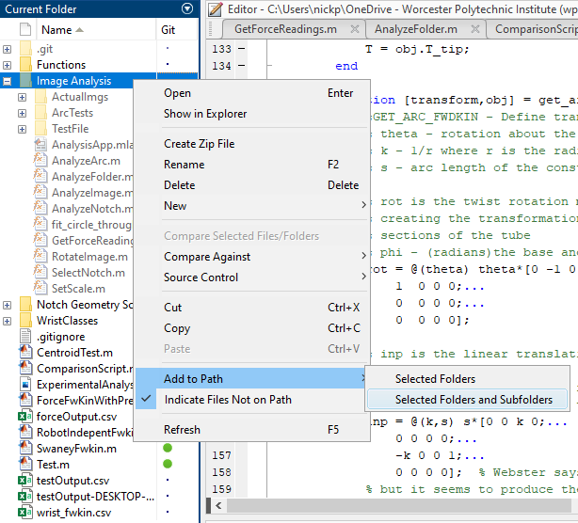

1. Know the path to the images you want to analyze (either relative to your current MATLAB directory or the absolute path)
   1. To find this, open the File explorer and locate the images
   2. Right click on the path in the File Explorer and click “copy address as text”

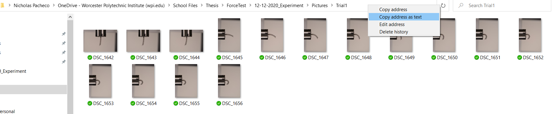

* 1. Save the path as a string variable in MATLAB or in a text file for easy access when we need it.
     1. * Make sure it ends in a “\”
     2. This will be an absolute path.

# Performing the Image Analysis

1. The main function that you will run is AnalyzeFolder which takes in the path to the images, the number of notches being analyzed per image, and false if the path is relative. Below are two examples (first one is for absolute path, second for relative path) for images with 5 notches.
   1. AnalyzeFolder(“C:\Users\nickp\MATLAB\Image Analysis\150BendTube1\”,false,5)
   2. AnalyzeFolder(“Image Analysis\150BendTube1\”,true,5)
2. If everything went well and MATLAB could find the images, a screen displaying the first picture in the folder will appear with instructions saying “Select notch to analyze”
   1. If MATLAB could not find the images the following output will appear in the Command window   
      AnalyzeFolder("150BendTube1",true,5)

ans =

0×5 empty double matrix

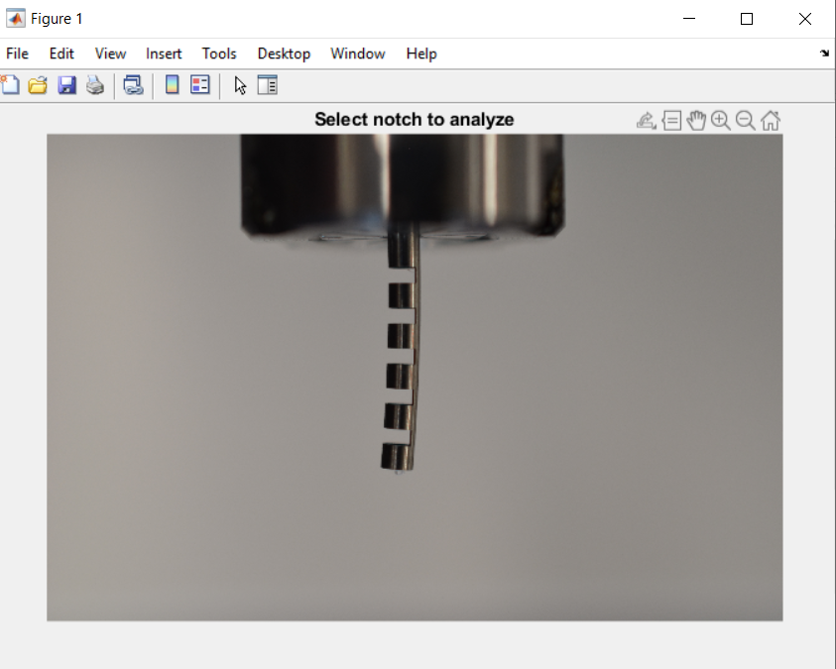

* 1. Check the path to make sure you are giving it the right location, and make sure you properly put in an absolute or relative path.

1. To select a notch, click and hold on the figure to draw a box around the notch.
   1. After you release the mouse, a dialogue box will pop up asking if you are happy with the box you created. If you are, select yes. If you are not, hit no or cancel, and redraw your box.
   2. When selecting the notches, I would recommend you start the most proximal notch and work your way to the most distal notch. It is important that you either go proximal to distal, or distal to proximal, and follow that pattern for each image.
   3. I would also recommend that your box covers the straight section on both sides of the notch to get the best results

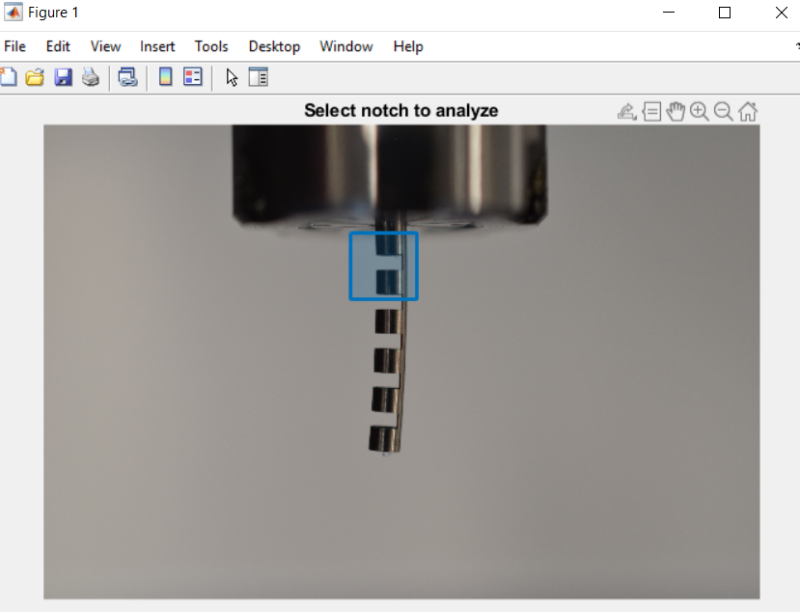

1. Once you are comfortable with your notch, you will be brought to a zoomed in picture of the region you had just selected. Here it is asking you to select points for the first line.
   1. The two points should be selected on the uncut section closest to the base of the tube.
   2. After selecting the two points, another dialogue box will pop up asking you to confirm your line.

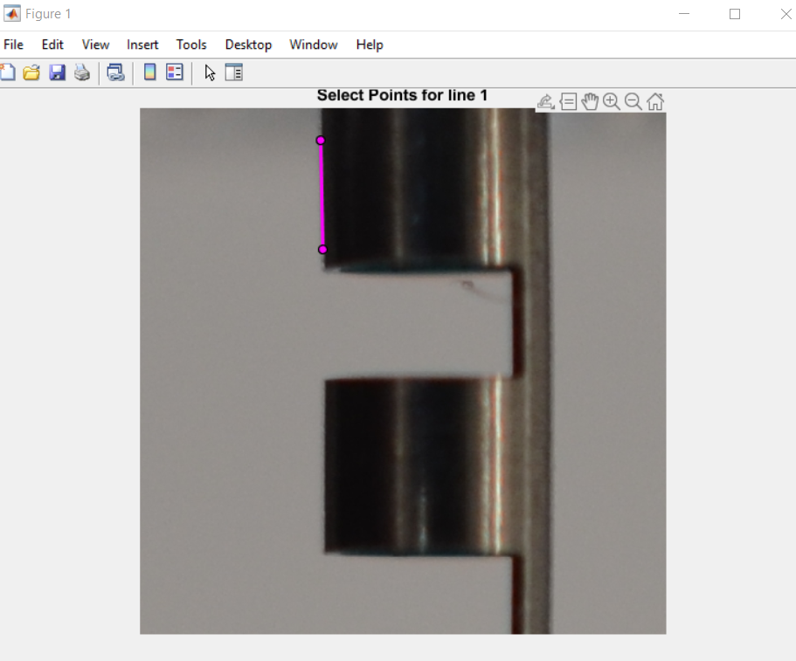

1. After confirming your first line, you will be asked to select points for line 2 which should go on the uncut section farther from the base of the tube.
   1. Another dialogue box will pop up asking you to confirm your second line

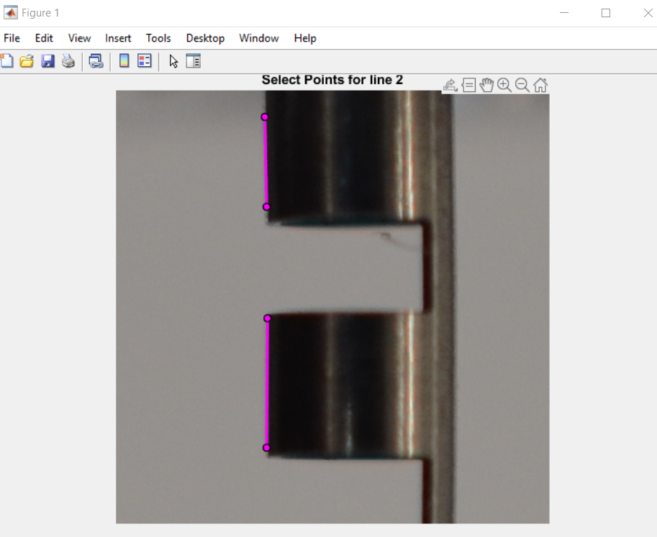

1. After confirming your second line you will repeat steps 2-6 selecting the next notch in the series
   1. The red outlines that will appear are meant to show you what notches you have previously selected so that you don’t have to keep track of them

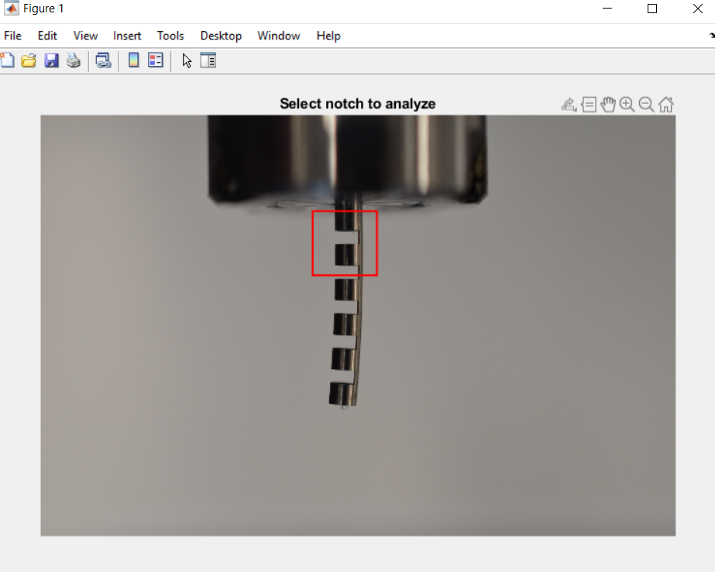

1. After performing the analysis on the first picture, the next image will automatically open to be analyzed.
2. After all the images have been analyzed, the data will be output to the Command Window and saved in a file ‘testOutput.csv’, that will be located in your current directory in MATLAB.
3. If you accidentally close out of the figure or need to stop halfway through analysis the previously analyzed images will be saved, but the current image will not.
   1. To pick up where you left off, get the image name that you quit on
   2. Then run the AnalyzeFolder function with two additional parameters: WriteMode, and Start File.
      1. WriteMode allow you to append to the current csv while start file will change which file you start on in the folder

AnalyzeFolder("Image Analysis\150BendTube1\",5,true, 'WriteMode', 'append', 'StartFile',"DSC_1447.JPG")